**Possible Certificate Issue**

The following issue may occur when you try to run the ‘Security Analysis’ feature under the ‘Advanced Analysis’ menu.

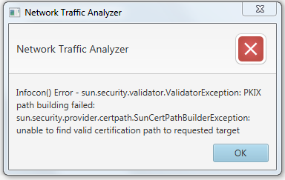

This appears because the server has self-signed certificate.

To work around this issue and get the application running on your local environment, you can add this certificate to the list of trusted certificates of your JVM.

If you see this issue on your environment, please follow the below steps to fix it.

* Go to [www.dshield.org](http://www.dshield.org) and export the certification. This can be accomplished (using Chrome) as follows:
  + Navigate to [www.dshield.org](http://www.dshield.org).
  + Next go to chrome://settings/, show advanced settings and click on ‘Manage Certificates…’.
  + In the dialog that find the below certificate, and use the export option to export it locally on your machine.



* Next we need to add this to the list of trusted certificates of our JVM. Go to your JRE_HOME/bin or JDK/JRE/bin
* Run the below command (substitiuting the path to your JDK directory and the path to the certification downloaded above.



* If promoted for a password, use the default keystore password ‘changeit’.
* When prompted to trusted the certificate, type ‘yes’.

The application should now work as expected.